Supplementary material

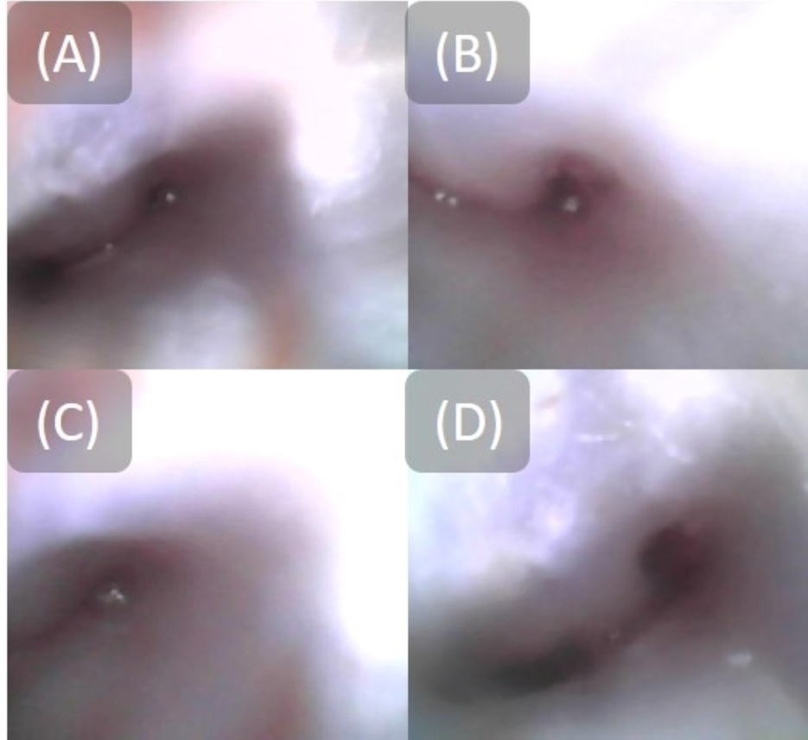

**Supplementary Fig. 1. Endoscopic view during file removal.** (A) The initial endoscopic view revealed the separated instrument in the apical area. A limited space near the instrument was barely visible in the coronal area. (B) The secondary endoscope view revealed the separated instrument slightly extruding from the root canal, approximately in the coronal area. (C) The separated instrument was completely loose. (D) The final endoscope view confirmed that no separated instrument remained in the canal.